DSA0502 – QUERY PROCESSING FOR DATA SCIENCE
CLASS ACTIVITY PROGRAMS
NAME: B KIRTHANAA REG. NO - 192324244
- Missing Value Imputation:
CODE:
import pandas as pd
import numpy as np

df = pd.DataFrame({
"Student":["A","B","C","D","E","F","G"],
"Marks":[75,82,np.nan,91,68,np.nan,84]
})

mean_marks = df["Marks"].mean()
print("Mean =", mean_marks)

df["Marks"].fillna(mean_marks, inplace=True)

print("\nDataset after Imputation")
print(df)

print("\nNew Class Average =", df["Marks"].mean())

OUTPUT:
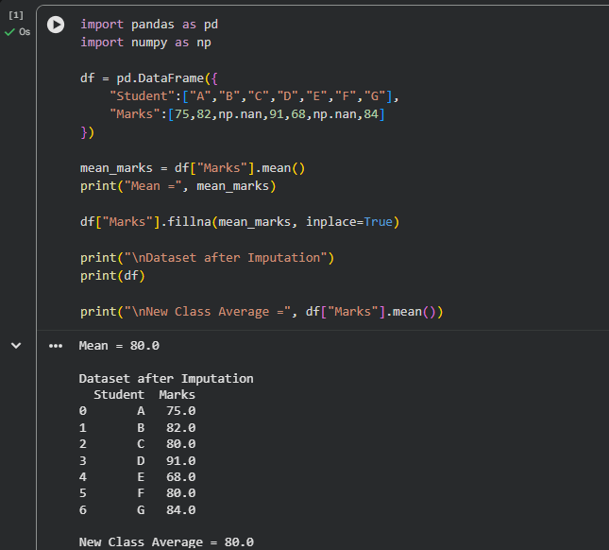
- Z-Score Outlier Detection
CODE:
mean = 61.22
std = 42.63
x = 180

z = (x - mean) / std

print("Z-Score =", round(z,2))

if abs(z) > 3:
print("Outlier")
print("Remove during Data Cleaning")
else:
print("Not an Outlier")

OUTPUT:
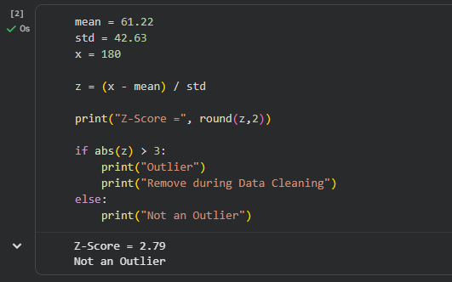

- Data Normalization
CODE:
import pandas as pd

salary = [42000,56000,70000,85000,98000]

mn = min(salary)
mx = max(salary)

norm = [(i-mn)/(mx-mn) for i in salary]

print("Normalized Salaries")
for i in norm:
print(round(i,2))

value = (70000-mn)/(mx-mn)

print("\nNormalized Value of 70000 =",round(value,2))
print("Minimum =",min(norm))
print("Maximum =",max(norm))
OUTPUT:
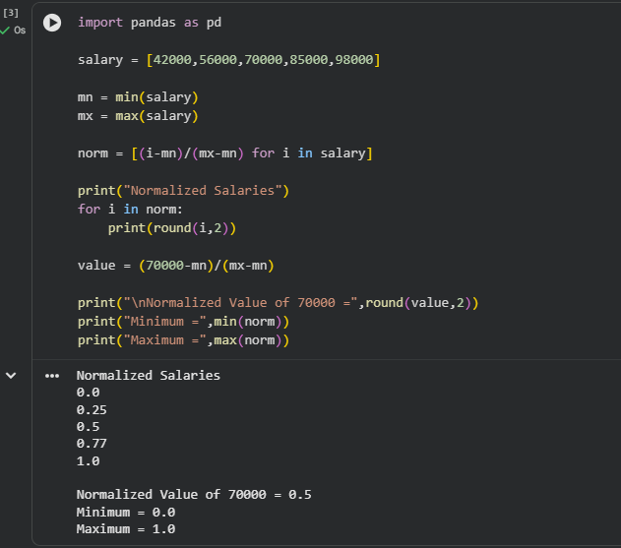
- Standardization
CODE:
score = 82
mean = 70
std = 8

z = (score-mean)/std

print("Z-Score =",round(z,2))

if score>mean:
print("Student is Above Average")
else:
print("Student is Below Average")
OUTPUT:
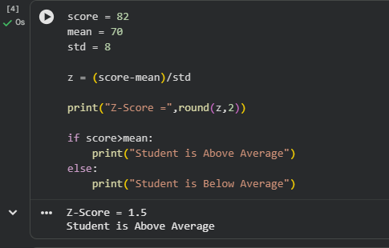

- SQL Numerical Problem
CODE:
import sqlite3
import pandas as pd

conn = sqlite3.connect(":memory:")

cur = conn.cursor()

cur.execute("""
CREATE TABLE Sales(
Product TEXT,
Quantity INTEGER,
Price INTEGER)
""")

data=[
("Laptop",8,45000),
("Mouse",25,650),
("Keyboard",15,1200),
("Monitor",10,14000)
]

cur.executemany("INSERT INTO Sales VALUES(?,?,?)",data)

query="SELECT SUM(Quantity*Price) AS TotalRevenue FROM Sales"
print(pd.read_sql(query,conn))

query="SELECT AVG(Price) AS AveragePrice FROM Sales"
print(pd.read_sql(query,conn))

conn.close()
OUTPUT:
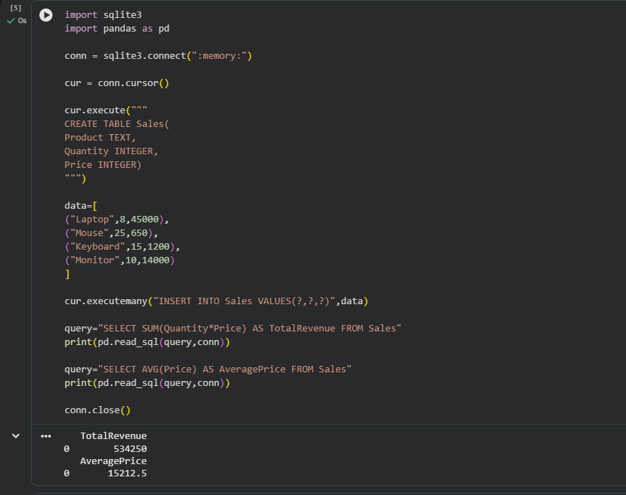

- Correlation Calculation
CODE:
import pandas as pd

x=[2,4,6,8,10]
y=[3,5,7,9,11]

df=pd.DataFrame({"X":x,"Y":y})

corr=df["X"].corr(df["Y"])

print("Correlation =",corr)

if corr>0:
print("Positive Correlation")
print("Increasing X increases Y")
OUTPUT:
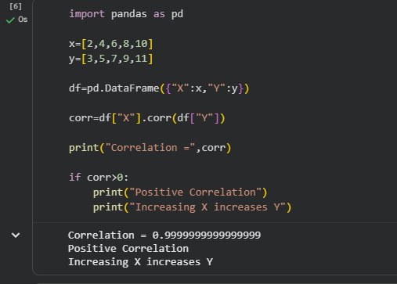

- Grouping and Aggregation
CODE:
import pandas as pd

df=pd.DataFrame({
"Region":["East","West","East","South","West","East"],
"Sales":[250,320,280,300,350,270]
})

print("Total Sales")
print(df.groupby("Region")["Sales"].sum())

print("\nAverage Sales")
print(df.groupby("Region")["Sales"].mean())

print("\nHighest Total Sales")
print(df.groupby("Region")["Sales"].sum().idxmax())
OUTPUT:
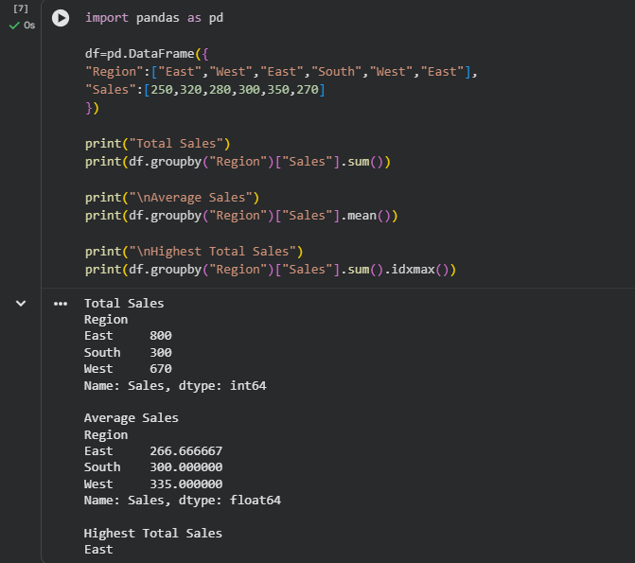

- Histogram Frequency Calculation
CODE:
import matplotlib.pyplot as plt

marks=[25,30,34,36,41,45,48,52,55,57,60,63,65,67,72,75,78,82,86,90]

bins=[20,40,60,80,100]

plt.hist(marks,bins=bins)

plt.title("Histogram")
plt.xlabel("Marks")
plt.ylabel("Frequency")

plt.show()
OUTPUT:
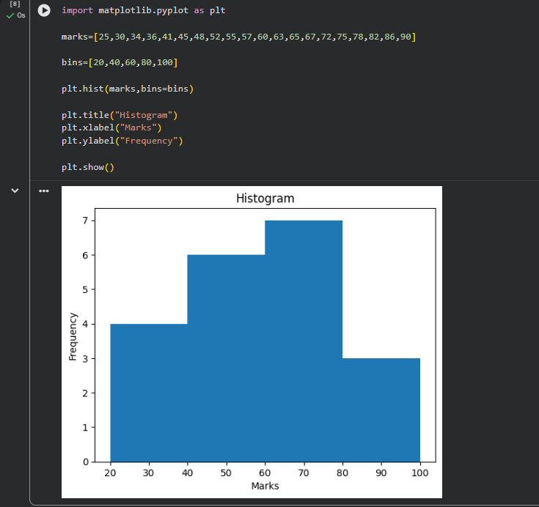

Frequency
CODE:
import pandas as pd

marks=[25,30,34,36,41,45,48,52,55,57,60,63,65,67,72,75,78,82,86,90]

bins=[20,40,60,80,100]

freq=pd.cut(marks,bins=bins,right=False).value_counts().sort_index()

print(freq)

print("\nHighest Frequency Class =",freq.idxmax())
OUTPUT:
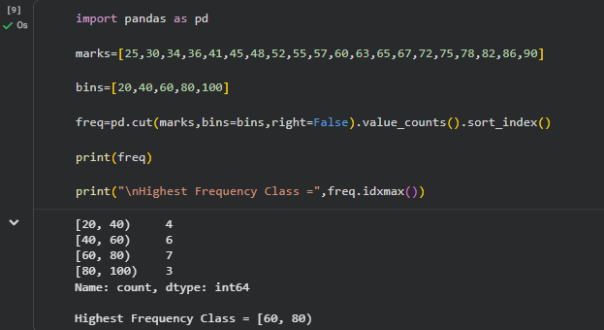

- Data Visualization Analysis
CODE:
import pandas as pd
import matplotlib.pyplot as plt

df=pd.DataFrame({
"Month":["Jan","Feb","Mar","Apr","May","Jun"],
"Sales":[45,52,49,61,70,65]
})

df["Growth"]=df["Sales"].diff()

print(df)

print("\nMaximum Increase Month =",df.loc[df["Growth"].idxmax(),"Month"])

plt.plot(df["Month"],df["Sales"],marker="o")

plt.title("Monthly Sales")

plt.xlabel("Month")

plt.ylabel("Sales")

plt.grid()

plt.show()
OUTPUT:
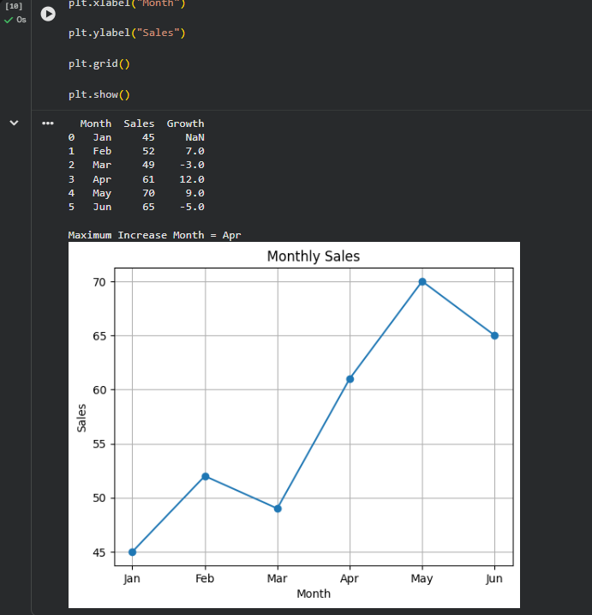

- Duplicate Detection and Percentage Reduction
CODE:
total=2500
duplicate=180
missing=70

unique=total-duplicate

dup_percent=(duplicate/total)*100

miss_percent=(missing/total)*100

clean=((duplicate+missing)/total)*100

print("Unique Records =",unique)

print("Duplicate Percentage =",round(dup_percent,2),"%")

print("Missing Percentage =",round(miss_percent,2),"%")

print("Total Cleaning Percentage =",round(clean,2),"%")

OUTPUT:
